**pit1 spring boot之 maven install 报错[Maven]**

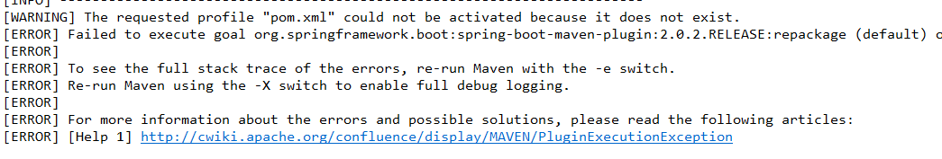

[ERROR] Failed to execute goal org.springframework.boot:spring-boot-maven-plugin:2.0.2.RELEASE:repackage (default) on project com.mutistic.boot: Execution default of goal org.springframework.boot:spring-boot-maven-plugin:2.0.2.RELEASE:repackage failed: Unable to find a single main class from the following candidates [com.mutistic.Application, com.mutistic.demo.DemoApplication] -> [Help 1]

[ERROR]

[ERROR] To see the full stack trace of the errors, re-run Maven with the -e switch.

[ERROR] Re-run Maven using the -X switch to enable full debug logging.

[ERROR]

[ERROR] For more information about the errors and possible solutions, please read the following articles:

[ERROR] [Help 1] http://cwiki.apache.org/confluence/display/MAVEN/PluginExecutionException

**问题描述：**@SpringBootApplication 注解类不止一个，导致maven install无法从以下候选人（com.mutistic.Application 和 com.mutistic.demo.DemoApplication）中找到一个主要的类。

原因：依赖的JAR未下载完毕、JAR冲突、JAR缺失、JAR损坏等问题。

**解决方案：**

使用主Application：com.mutistic.Application 。 将 com.mutistic.demo.DemoApplication 的@SpringBootApplication注释掉

